4. RUNGE-KUTTA 4th ORDER METHOD

AIM: AIM: TO WRITE A PROGRAM IN PYTHON TO DEMONSTRATE RUNGE-KUTTA 4th ORDER METHOD
PROGRAM:
RK4 step-by-step for y' = x + y, y(0)=1
import math

def f(x, y):
"""The ODE: y' = x + y"""
return x + y

def exact_solution(x):
"""The exact solution of y' - y = x with y(0)=1 is y = 2*e^x - x - 1"""
return 2 * math.exp(x) - x - 1

# Initial values
x = 0.0
y = 1.0
h = 0.1
steps = int(0.2 / h) # Compute up to x = 0.2 (steps = 2)

print("Runge-Kutta 4th order (RK4) step-by-step")
print(f"Equation: y' = x + y, y(0)={y}")
print(f"Step | x_n | y_n (before) | k1 | k2 | k3 | k4 | y_{steps * h:.1f}")
print("-" * 100)

for n in range(steps):

# RK4 coefficients
k1 = f(x, y) * h
k2 = f(x + h/2.0, y + (k1/2.0)) * h
k3 = f(x + h/2.0, y + (k2/2.0)) * h
k4 = f(x + h, y + k3) * h

# RK4 Update Formula
increment = (h/6.0) * (k1 + 2.0*k2 + 2.0*k3 + k4)
y_next = y + increment

# Print step details
# Using 'n' for the step count (0 and 1) and 'n+1' for the y_next index (1 and 2)
print(f"{n+1:3d} | {x:6.3f} | {y:16.10f} | "
f"{k1:7.6f} | {k2:7.6f} | {k3:7.6f} | {k4:7.6f} | {y_next:10.9f}")

# Update
x += h
x = round(x, 10) # avoid floating accumulation
y = y_next

print("-" * 100)
# Final output
exact_y = exact_solution(x)
absolute_error = abs(y - exact_y)

print(f"Final RK4 approximation: y({x:.3f}) = {y:.9f}")
print(f"Exact value : y({x:.3f}) = {exact_y:.9f}")
print(f"Absolute error : |abs({absolute_error:.12e})")

OUTPUT:
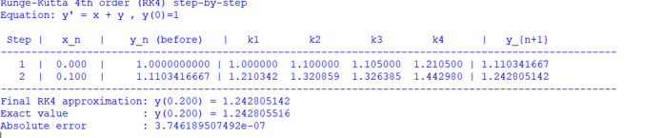

CONCLUSION: THE ABOVE PROGRAM HAS BEEN EXECUTED SUCCESSFULLY,

